Giant buil
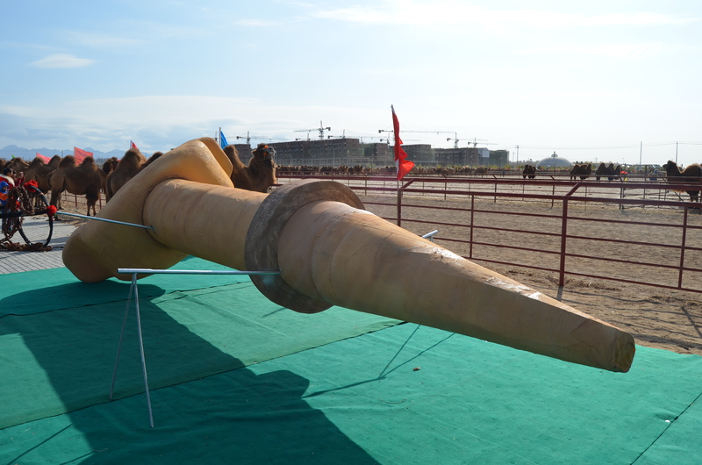

identifier
e1fc321f-3268-443e-8260-1d4667ada44b

creator
White, Thomas

type
Image

coverage
Alashan
Inner Mongolia
PRC

description
A giant buil -- the wooden peg inserted through the nose of a camel and used for attaching reins or tethers -- on display at the camel festival.

publisher

source
Image submitted by the author.

rights
Copyright Thomas White. All rights reserved. Please contact the author for information on re-use.

subject
camels

date
2013-11-09 05:11:08

language

format
image/jpeg

contributor

original filename
giant buil.JPG

relation

extent
4.2MiB
4928x3264 px

